

**Report on Design Thinking Project**

**Subject : Technology and Information Systems (SECP 1513)**

**Section : 07**

**Name of Lecturer : Dr. Azurah**

**Date : 30.11.2023**

**Title of Design Thinking Product : Smart Helmet**

**Video Link (youtube) : https://youtu.be/QQawlG4Hl0o**

## **Group Profile**

| **Name: Mohammad Irfan Danial Bin Kefli**  **Matric Number: A23CS0113**  **E-mail: irfandanial2004@gmail.com**  **Phone number: 010-9874625**  **Course: Faculty Computing(Software Engineering)**  **GitHub link: https://github.com/irfandanial04/ePortfolio-SECP1513-05.git** | **Name: Yong Jing Wen**  **Matric Number: A23CS0202**  **E-mail: yongj3188@gmail.com**  **Phone number: 011-10530746**  **Course: Faculty Computing(Software Engineering)**  **GitHub link: https://github.com/JWEN0518/E-PORTFOLIO-SECP1513/tree/6b64d0b921c59a8a1cb6a5b6e1817d1be8abbc16** |
| --- | --- |
| **Name: Wong Shi Yun**  **Matric Number: A23CS0198**  **E-mail: wongshiyun@graduate.utm.my**  **Phone number: 010-8737295**  **Course: Faculty Computing(Software Engineering)**  **GitHub link: https://github.com/Weee7295/e-portfolio** | **Name: Muhammad Gibran Dzikry**  **Matric Number: A22EC4036**  **E-mail: thisisgibrandzikry@gmail.com**  **Phone number: +62811513996**  **Course: Faculty Computing(Software Engineering)**  **GitHub link: https://github.com/PseudoGib/SECP1513-05/tree/main** |

**CONTENTS**

| **NO.** | **TOPIC** | **PAGE** |
| --- | --- | --- |
| 1. | INTRODUCTION | 4 |
| 2. | DETAIL STEP AND EVIDENCE FOR EACH PHASE | 5 - 6 |
| 3. | DETAILED DESCRIPTIONS | 7 |
| 4. | DESIGN THINKING ASSESSMENT POINT | 8 |
| 5. | DESIGN THINKING EVIDENCE   1. SAMPLE WORK 2. RECORD FOR EACH PHASE - i. Empathy   ii. Define  iii. Ideate  iv. Prototype  v. Test | 9  10  11  12  13 - 15  16 |
| 6. | REFLECTIONS | 17 - 19 |

**INTRODUCTION**

In this report, we are discussing the process of design thinking and the problems that people are facing nowadays. The title of our design thinking is ‘Smart Helmet’. We have used the helmet that already exists in the market and evolved it to become a product that is more satisfying to customer’s needs. Our purpose in doing this ‘Smart Helmet’ is safety first. Motorcycles are used as a means of transportation. It is an indispensable thing in our daily life. When we are riding a motorcycle, the most important step is to wear a helmet to prevent injury to our brain. During the research, we found that in Malaysia there have been a lot of motorcycle accident cases. To worsen the situation, some people may lose their lives in motorcycle accidents. We found that the main reasons why the accident happened were the road conditions and the weather. It is very dangerous when the rider is riding on a rainy day because the motorcycle can’t be controlled easily by the rider on a winding road or due to some emergency we are forced to break suddenly. Besides, it is hard for riders to be aware of the road without any psychological preparation and notification. Therefore, they cannot react immediately when they encounter road holes. At that time an accident may happen. Through this issue mentioned by the above statement, we have decided to create the ‘Smart Helmet’ to solve this problem effectively.

**DETAIL STEPS AND EVIDENCE FOR EACH PHASE**

Before we start our project, we need to do some research to have a better understanding of our project. First and foremost, we need to find the problems from the rider’s perspective. For example, we must know what the rider feels, thinks, and faces while riding. This can help us in doing a project that can fulfill the requirements of the riders and try to solve the problem. We have decided to interview with one of the riders who has a driver’s license for 2 years.

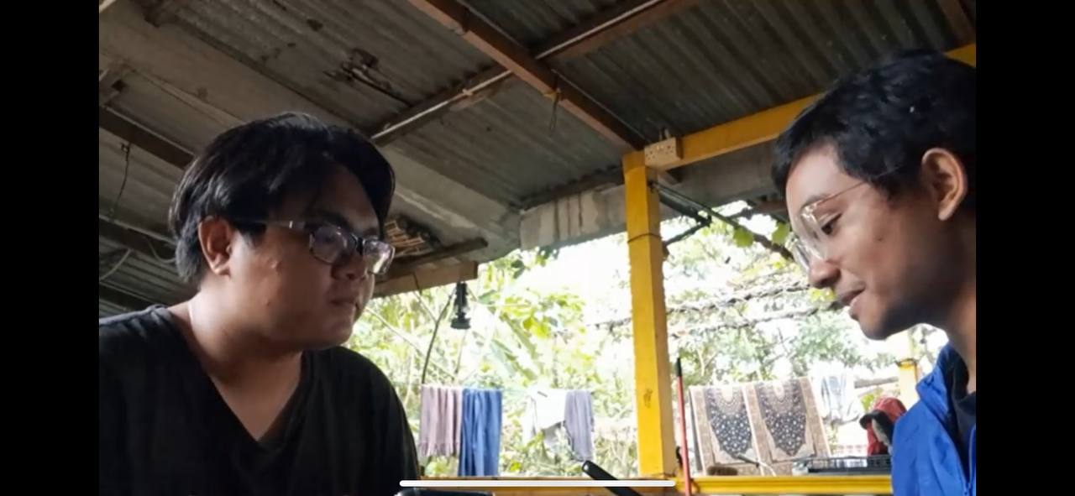

( Interview session with rider)

Based on the interview, we have discussed as a rider what problem they are facing. During the interview, he/she also gave us a lot of helpful information for us to improve our design. The most interesting part is about the side mirror on the motorcycle because we didn’t expect that the side mirror is one of the problems that the rider is facing. Lastly, we can consider our whole interview process from preparing the question to the end of the interview was very successful.

After we have discovered the problem, we start to sort out the issues from the interviewee and list them down so that it is better for us to understand and find out the solution. We successfully found 2 problems that riders are facing nowadays. This phase is called the define phase.

The next phase is the ideate phase. The ideate phase is a brainstorming process. We want to find out a solution that can solve the problem that the rider facing. Therefore, we have to do the online discussion through the google meet. All of us have given some solutions based on the problem that we found.

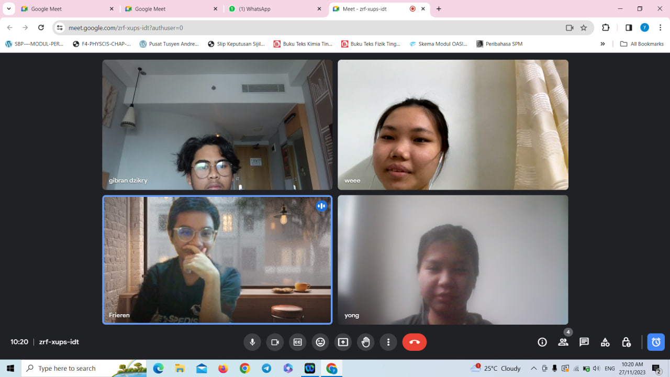( Discussion via Google Meet)

Throughout the brainstorming process, we have found the most suitable solution to solve all of the problems. We use the ‘All in one’ concept which means we put all the functions or features into one helmet. Next, let’s go to the prototype phase in which we need to convert our imagination to our physical product.

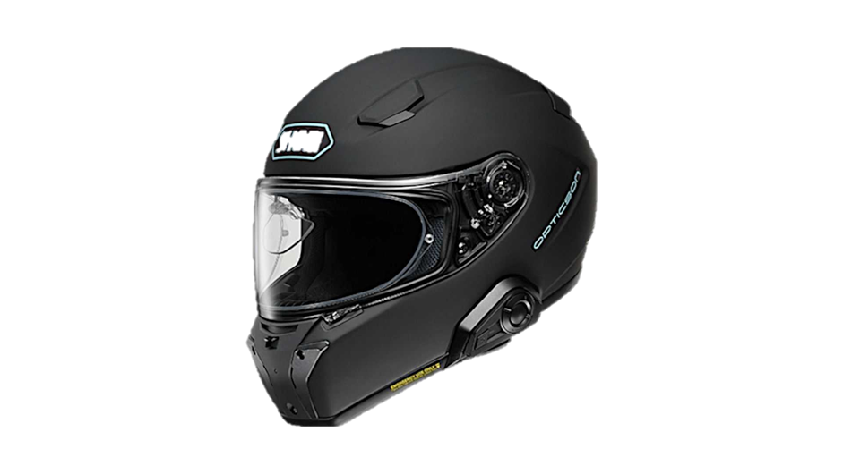

(“Smart Helmet”)

The last step is testing. It is the most pivotal step because this step can prove whether our product is successful or not. Besides, through this testing, we can find out our product’s weaknesses and try to make some improvements until it becomes more complex. Along this testing, we can hear from the different tester opinions.

**Detailed descriptions**

There are many obstacles we encountered while completing this assignment. Firstly, most group members are not available in school during the mid-term semester break for first year students. This results in difficulties in having face-to-face group meetings. Thus, we had our group meeting online via Google Meet. As for second year students, they are busy with tests at this period. As a result, we have to adjust our meeting time to involve every group member in a limited time. Besides, it is hard for us to find interviewees as most of them are shy and refuse to appear on camera. It took time for us to convince the interviewee. As this is a group work, we also allocated different tasks to each member.

**DESIGN THINKING ASSESSMENT POINT**

Every member of this group has done their best in each phase of the given assessment. The member who conducted the interview with a driver was able to capture all the complaints from the driver about his job. By conducting an interview with a driver, we were able to understand more deeply about the driver's view of his job. And with the completion of the interview, we were able to delve deeper into the meaning of the problems we found and define them so that we could propose existing solutions. We discussed and got several ideas that could solve the problems experienced by the drivers. All members provided brilliant and good ideas. With the ideas that have been generated, we started to make a prototype of the product we proposed. The first prototype is still very lacking, but from there we can find gaps to add updates. After making the first prototype, we found another driver and tested the prototype. The response from the driver was quite satisfying, but of course, there is still room for us to make our project better.

**DESIGN THINKING EVIDENCE**

Sample Work

There are sample works by us working to solve the design challenge

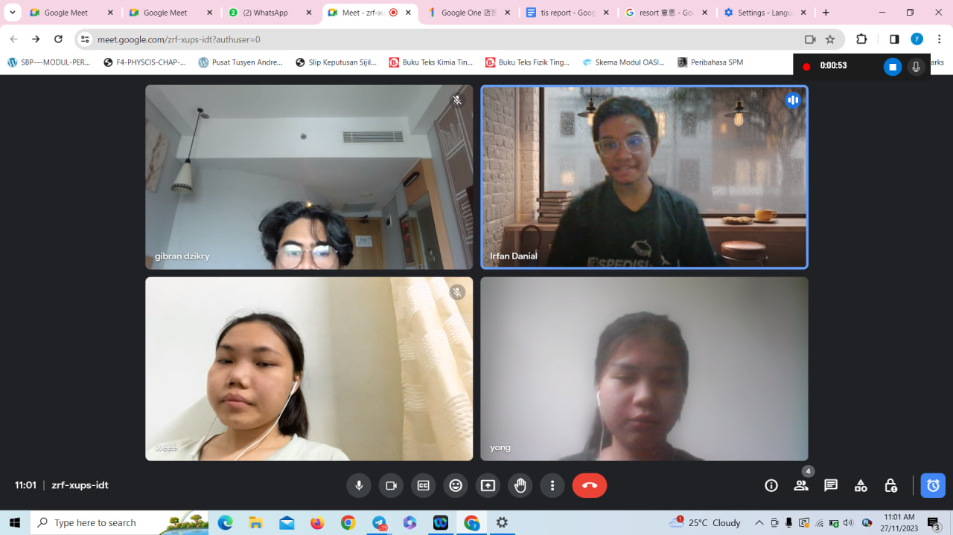

In this picture, we were talking about the problem that riders faced, the brainstorming process, and how to develop the prototype.

Record For Each Phase

i. Empathy

The first stage of Design Thinking is empathy. Empathy is the process by which we must stand with our clients' needs. Empathy is an important step as it will guide you to get most of the information from the user. To empathize, first, we must observe and study the attitudes of the client to understand their needs. Next, is engagement which is when we approach the client to get information and what problem he/she is facing. Finally is immerse, which means we should put ourselves in their shoes so we can feel how the user felt about that situation. All these crucial steps would help us to deeply understand and be able to solve the problem that is faced by the user thoroughly.

**The interviewee**

Therefore, we conducted an interview with Aiman Afiq Bin Zamzuri to ask some questions about the problems that the riders are facing so that we can improve our design.

Interviewee Profile Info

Name: Aiman Afiq Bin Zamzuri

Age: 20

Education: Bachelor of Mechanical Engineering with Honour (Manufacturing)

University: University Teknologi Malaysia

The first problem that he mentioned was the side mirrors are inconvenient for the rider. This is because it causes difficulty for riders to overtake other vehicles, especially during heavy traffic or encountering traffic lights. If they make a small mistake, the side mirror might collide with another vehicle thus causing a small accident. The interviewee also told a story about how he once collided with another car but fortunately, the other driver is a good guy. He also stated why these days riders, especially teenagers, are removing side mirrors from their motorcycles even though they acknowledge that it is against the law.

After that, the interviewee is also having a problem with the motorcycle’s phone holder because it is sometimes distracting. It might even cause accidents if riders are not responsible enough and use the phone such as watching YouTube while riding. Other than that, if they do not put their phone on the holder properly, their phone might break or even go missing while they are not aware of it. Thus, it would cost them more and bring more problems since smartphones are not that cheap nowadays.

II. Define

* The existence of side mirrors

It is very difficult when the rider tries to overtake between vehicles, especially at the traffic light. Sometimes the side mirrors may cause a small accident due to collapse between side mirrors from different vehicles.

* Difficult to check the road conditions and weather while riding

Motorcycle does not provide a device that allows us to look for a route or to check for

the weather by using apps such as Google Maps just like in a car or lorry. Hence, all

riders have to use external devices for navigation such as smartphones that will be

place on motorcycle’s phone holder. Looking at the phone while riding a motorcycle

may cause distraction to the rider thus bringing danger to other road users. The

smartphone may also break or even be lost when placed on the phone holder due to the

unpredictable weather or might fall from the motorcycle.

III. Ideate

Ideate is the third stage of Design Thinking. In this stage, all of us brainstormed to provide solutions for the problem we obtained from the last stage. We had a discussion on Google Meet and collected a few ideas.

| Problems | Solutions |
| --- | --- |
| side mirrors | * camera with 360 view to replace side mirrors * distance tracker to monitor the distance between the motor and other vehicles |
| weather and road conditions | * Head-up display on the windshield for any purpose * modified phone holder to an integrated screen like a car display |

At the end of the meeting, we decided to modify the usual helmet to a smart helmet by adding a 360-view camera on top and a head-up display on the windshield of the helmet. The display screen combined all features needed such as showing what the camera captured for riders to track distance and has a 360 view around the motorbike. Besides, it connects to the phone and gets access to applications such as Waze and weather forecast.

IV. Prototype

Through the problem and solution that we had found, we need to implement our product for rider testing. Our product is called “Smart Helmet’. It uses the concept of “All in one” which includes all the functions in a helmet. Let’s see how can we activate this feature.

We had designed a logo for our “Smart Helmet” with the motto” Safety First”.

Besides, our helmet contains wireless headphones with a microphone. This feature can be activated by our voice control and the integrated smart screen on the windshield of the helmet will display it.

There are a few steps to activate the helmet. The first step is pressing the power of our “Smart Helmet”.After that, setting your voice so the helmet can recognize your voice. Furthermore, the integrated smart screen on the windshield of the helmet will display the map when we want to search for the way that we want to go and display the road conditions and weather when we want to know the latest information so that we can know in advance the road condition and weather. The feature of a 360-degree view camera on the top of the helmet instead of the side mirror. When riders want to turn left or right, move forward or reverse, the integrated smart screen will automatically show the surrounding view.

1. Logo of ‘Smart Helmet”

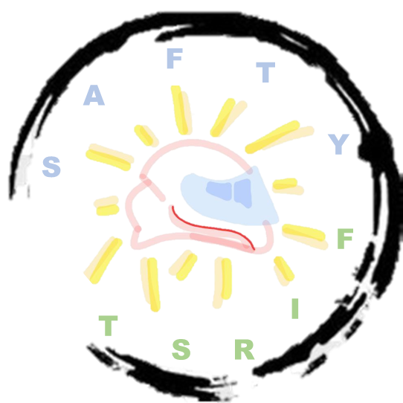

2. Overview of our products

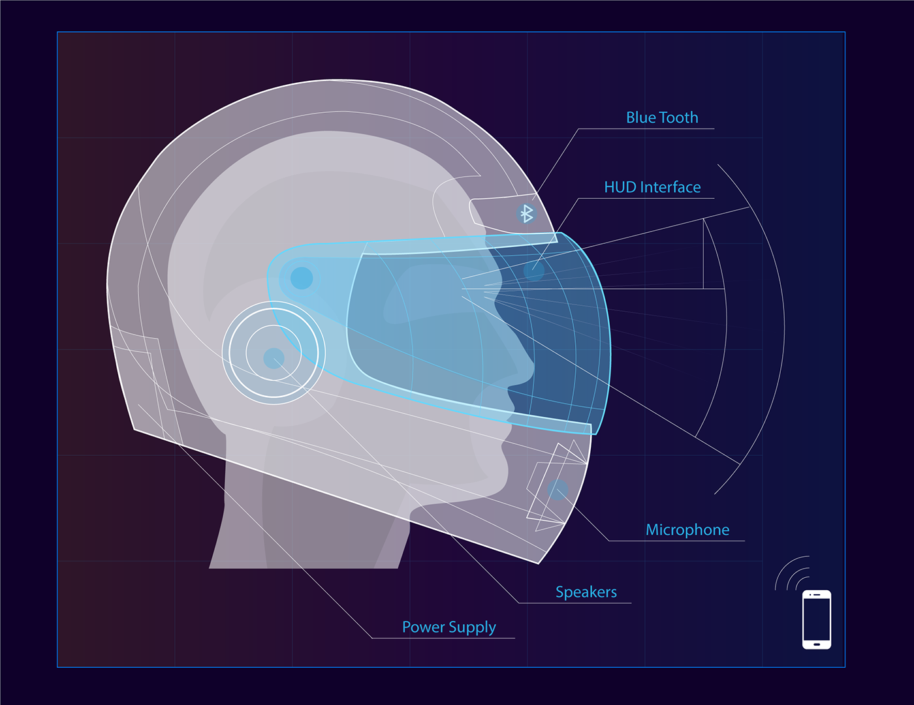

2. Feature of 360-degree view camera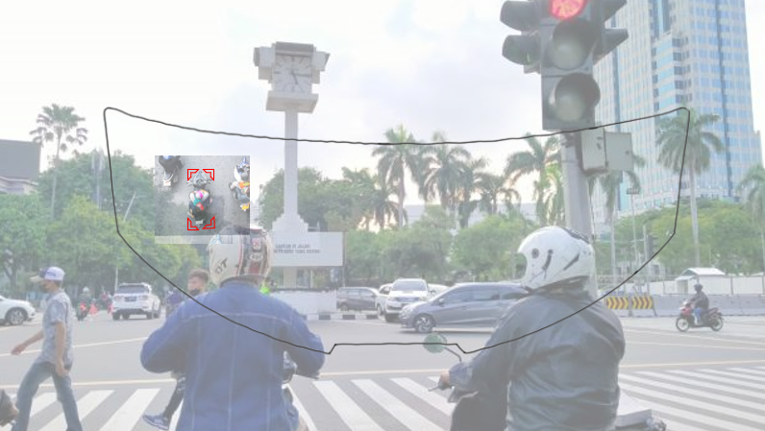

3. Map on the smart screen

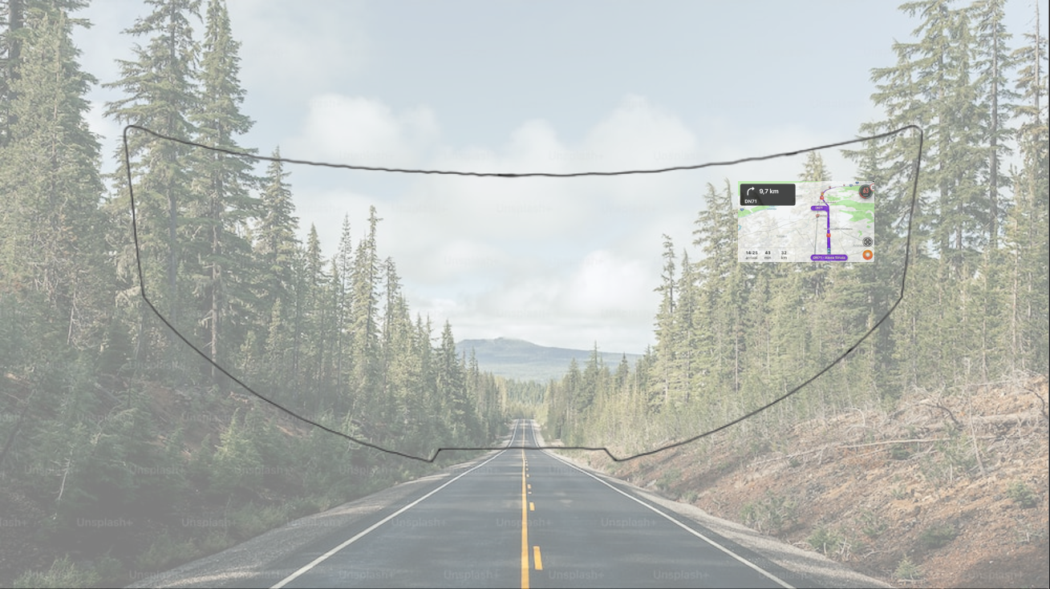

4. Weather on the smart screen

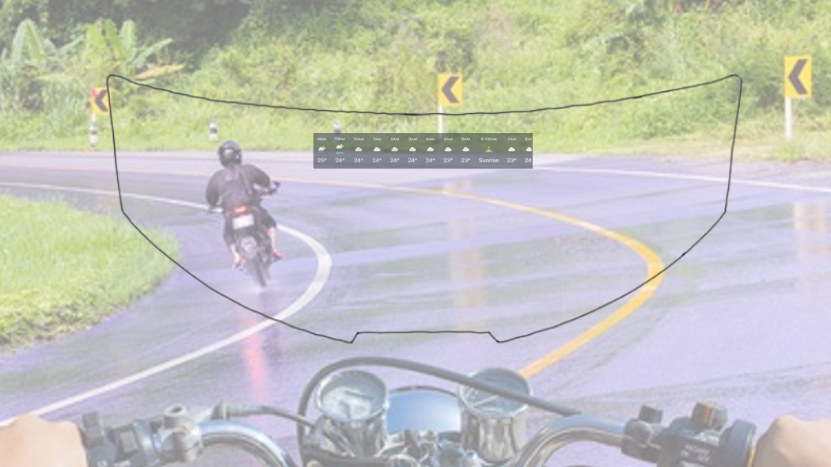

V. Test

In this phase, we will conduct a trial of our first prototype with a driver, where the driver's response and feedback will serve as our reflection material for making improvements. In this first prototype, the highlighted features are those of the "smart helmet" itself. The features in question are incoming order notifications, weather notifications, and a floating map that can be minimized and maximized, as well as a vehicle alert feature, which is activated when a vehicle gets too close to the driver. During testing, the driver was amazed by the features. The driver did not forget to provide comments such as the 360 camera being quite strange on top of the helmet, and the map feature needing optimization. Of course, the driver's response provides us with reflection material to continue making improvements. With a fairly positive response, we are quite confident that if this product is realized, it will attract quite a lot of interest, and of course, the driver also hopes for the same.

REFLECTION

By Yong Jing Wen

My goal is to become a software engineer that can give a lot of benefits to people and improve the technology and economic development in our country. This is the reason why I want to be a programmer to develop and innovate some apps with high security that can make people's lives more convenient.

Through this design thinking I had learned that teamwork and cooperation is most significant and is the main key to success. By doing the project in a team, we can solve the problem more effectively and productively. In addition, the second impact is I had learned that problems should be found from different perspectives. This can let my innovation be more in line with the people’s needs.

I need to improve my programming techniques skills in a variety of programming languages by watching videos on YouTube and doing a lot of exercises about programming. However, I noticed that doing exercise is not enough for me to improve my programming skills. I should participate in programming competitions or involve myself in any project related to programming to find my shortcomings.

By Wong Shi Yun

As far as I know, software engineers are responsible for designing, developing, testing, and maintaining software applications. They work with clients and end users to build software solutions that meet their needs and expectations. It is undeniable that they contributed to all the applications in the market and made life and daily tasks easier. For example, we get to study online via meeting applications such as Zoom and have our meals or parcels delivered with just a few taps in delivery apps like Grab. I had deeply experienced those conveniences while in control movement order and the social impact from them by developing software to address social issues. Therefore I dreamed of becoming one of them.

​

​Design thinking provides a solution-based approach to solving problems. I learned how to create a product that meets the needs of users. It is not just my idea to innovate something, but have to relate to users' demands and solve the problems. By testing the prototype, I understood the importance of refinement to ensure our solutions were user-friendly and effective. Design thinking encourages me to think creatively and develop solutions to problems which are somehow similar to the software development life cycle.

Improvement in programming skills will be the most necessary plan to improve my potential in the industry. Besides learning from class, I should do some self-learning on other programming languages such as Python and Java via Udemy or Coursera. Other than that, communication skills is also crucial to improving potential in the industry. I should practice concisely explaining ideas and solutions.

By Mohammad Irfan Danial Bin Kefli

As a future software engineer, my top priority is to learn and develop all skills that are essential in this industry. To acquire these skills, first I must pay full attention during classes and ask about something that I don’t know from my fellow peers or lecturers. Then, I should not only rely on the class but also study by myself since there is a lot of material that is distributed for learning on the internet such as on Youtube. By mastering all the theoretical and practical knowledge for this course, I believe that I can be a capable software engineer that is in demand by all companies. Thus being able to produce software applications such as WhatsApp that we use on a daily basis.

From this design thinking, I have managed to acquire so many different new soft skills and knowledge. First and foremost it gives me the opportunity to think critically as this skill is the most important when you are developing a software to meet the requirement that is needed by the user. Furthermore, I am also able to learn on how to work with a team as we are required to distribute tasks equally so that there is no one who is dissatisfied with the work given. Subsequently, improving my communication skills as communication is the most crucial part when you are at work so that there is no misinformation among team members. Not to forget, I am also able to enhance my editing skill when I am editing the video by using software such as Capcut. Finally, this design thinking project is able to teach me and gives experience on how to execute at some project given when I have already worked in this industry in the future.

Finally, I am thinking of improving my programming skills as it is the main core of my program. Not only that, learning other programming languages such as Java and Kotlin can also increase my market value. Not to forget, my plan is to acquire as many qualified certificate as much as I can to enhance my resume so I can be better in this industry.

By Muhammad Gibran Dzikry

Being a student in the Software Engineering department is quite challenging, and I have to strive for it. To achieve the title of a Software Engineer, I have to overcome many obstacles. I realize that I still need to learn a lot, and I also have to gather many skills. Perhaps all of this will start from here. I will devote more time to improving my learning methods, because just listening to lectures is not enough for me.

From this design thinking project, I gained a lot of new skills and I was able to explore other skills that I didn't even know I could do, but eventually, I tried. In this project, I was entrusted to do prototyping and testing on a driver. From there, I was able to hone some of my skills such as craftsmanship and communication. Of course, I want to add other skills, and of course, writing this report requires writing and critical thinking skills, so this is also training for that.

Finally, with this project, I was able to utilize my skills and increase my knowledge. I look forward to the next stages of the project and future projects. Collaborating with the people in this group has helped me hone my skills. They are great people and I am grateful to be able to work with them. I look forward to another time to be able to collaborate with them at another time. I also understand that I need to learn more so as not to be left behind by others. Because I also have a dream to become someone who is proficient in the field that I choose.